Safe Guarding Organisations who can help

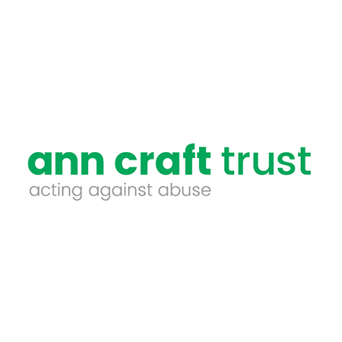
The Ann Craft Trust helps keep people safe from abuse.
As a leading authority in safeguarding adults and young people at risk, the Trust wants to help create a world where people live safely, free from the risk of abuse.
Through pioneering training, practice reviews and contributing to world-leading research, the Trust supports organisations to safeguard adults and young people at risk and minimise the risk of harm.
The Trust’s work is dedicated to key issues affecting adults and young people at risk including forced marriage, financial abuse, sexual exploitation and disability hate crime.
You can find out more about the Ann Craft Trust at https://www.anncrafttrust.org/ or for advice, call 0115 951 5400.

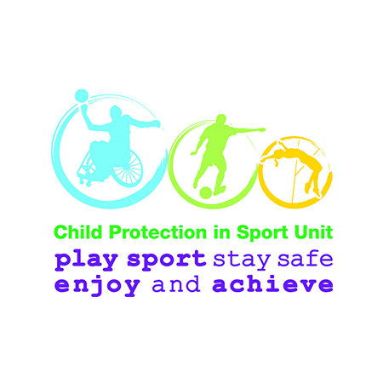
The Child Protection in Sport Unit (CPSU) is a partnership between the NSPCC, Sport England, Sport Northern Ireland and Sport Wales. (In Scotland, there's a similar partnership between Children 1st and Sport Scotland.)

The Unit was founded in 2001 to work with UK Sports Councils, National Governing Bodies (NGBs), County Sports Partnerships (CSPs) and other organisations to help them minimise the risk of child abuse during sporting activities. Its mission is to build the capacity of sports to safeguard children and young people in and through sport and to enable sports organisations to lead the way in keeping children safe from harm.

For more information on the CPSU you can find resources, webinars and other information at thecpsu.org.uk or contact CPSU at cpsu@nspcc.org.uk

Childline is a free, private and confidential service where you can be you. It exists to help anyone under 19 in the UK with any issue they’re going through. Whether it’s something big or small, their trained counsellors are there to support.
Childline is free, confidential and available any time, day or night. You can talk to Childline on the phone, by email or through 1-2-1 counsellor chat. Whatever feels best for you.
- Childline can help with anything – from abuse and bullying to exam stress and relationships;
- Call Childline on 0800 1111 or go to the childline.org.uk for advice and support.

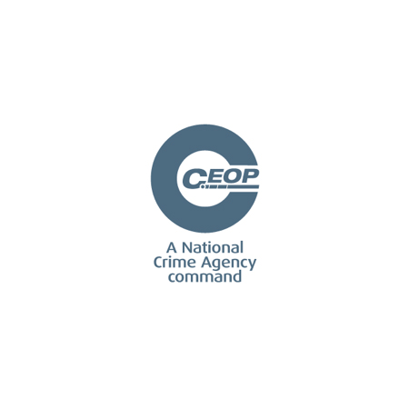
The Child Exploitation and Online Protection Centre (CEOP) works with safeguarding and child protection partners across the UK and overseas.
It protects children from harm online and offline with a focus on child sexual exploitation and online protection issues.
If you work with children and young people or are a parent and want to know more about keeping children safe online, you can use CEOP's Thinkuknow education resources.
If you are worried that someone has acted inappropriately towards your child or another child you may know or work with, you can report this. This may include things like sexualised chat, being asked to meet up, or being asked to do something that made the child feel uncomfortable.
Any member of the public - whether a child, parent or professional - can report a concern about child sexual abuse or online exploitation to the CEOP safety centre.
All reports are assessed and responded to by CEOP's specialist Child Protection Advisors. If a police response is necessary, it would be conducted in partnership with your local police force. Please remember that if a child or young person is in immediate danger then always call 999.

The National Society For The Prevention Of Cruelty To Children (NSPCC)
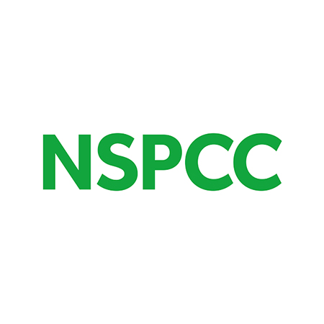
The National Society for the Prevention of Cruelty to Children (NSPCC) Are the leading children's charity fighting to end child abuse in the UK and Channel Islands.
Alongside The FA’s own procedures for responding to, and reporting concerns about a child, The FA promotes the use of NSPCC helpline: 0808 800 5000 This line responded to almost 55,000 contacts from adults concerned about the welfare of a child last year.
The NSPCC helpline is open 24hrs a day and is a place adults can contact by phone or online to get advice or share their concerns about a child, anonymously if they wish. It's staffed by professional practitioners with backgrounds in jobs like teaching, healthcare and social work, who know how to spot the signs of abuse and what to do to help.
If you have concerns about a child or young person please contact the NSPCC helpline on 0808 800 5000 or by emailing help@nspcc.org.uk
Whatever the issue, the NSPCC is there 24/7 to keep children safe.

Sporting Chance
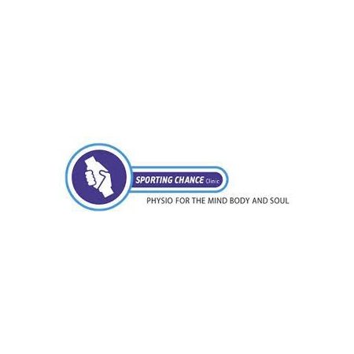
Inspired by his own recovery from alcoholism and founded in the year 2000, Sporting Chance is the brainchild of former Arsenal and England captain Tony Adams, MBE.
Based on his experience, and what he felt was lacking, Tony saw the need for a safe, dedicated environment where current and former sportsmen and women could receive support and counselling for the kinds of destructive behaviour patterns that exist in the world of competitive sport, but that are often denied.
Sporting Chance has since developed into one of the world's most innovative centres for the treatment of behavioural problems among professional and former professional sportspeople.
Sporting Chance can be contacted on 0870 220 0714 or via https://www.sportingchanceclinic.com/

The Mix is a leading support service for young people.
They exist to help young people face any challenge they’re facing – from mental health to money, from homelessness to finding a job, from breaks-ups to drugs.
You can contact The Mix via their online community, on social media, and through their free confidential helpline: 0808 808 4994.
A counselling service is also offered. Details on all The Mix’s services can be found on their website here.

