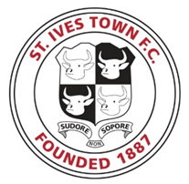
BOOKING SHEDULE FOR THE MASCOTS
FIXTURE | DATE | MASCOT TEAM | AVAILABLE  DATE | COMPLETED BOOKING
Merthyr Town | Sat 30th Sep
Tiverton Town | Sat 7th Oct
Weymouth | Sat 21st Oct
Dunstable Town | Sat 11th Nov
Frome Town | Sat 18th Nov
Banbury United | Sat 2nd Dec
Gosport Borough | Sat 23rd Dec
St Neots Town | Mon Jan 1st
Slough Town | Sat 13th Jan
Royston Town | Sat 22nd Jan
Redditch United | Sat 10th Feb
Farnborough | Sat 24th Feb
Stratford Town | Sat 10th Mar
Chesham United | Sat 17th Mar
Basingstoke Town | Sat 31st Mar
Dorchester Town | Sat 14th April
Hereford | Sat 28th April

Please be aware that all fixtures kick off at 3pm
Mascots/ parents to arrive at 2.15pm outside the turnstile.

